* Uploaded the URL of your GitHub repository including all the completed notebooks and Python files (1 pt)
* Uploaded your completed presentation in PDF format (1 pt)
* Completed the required Executive Summary slide (1 pt)

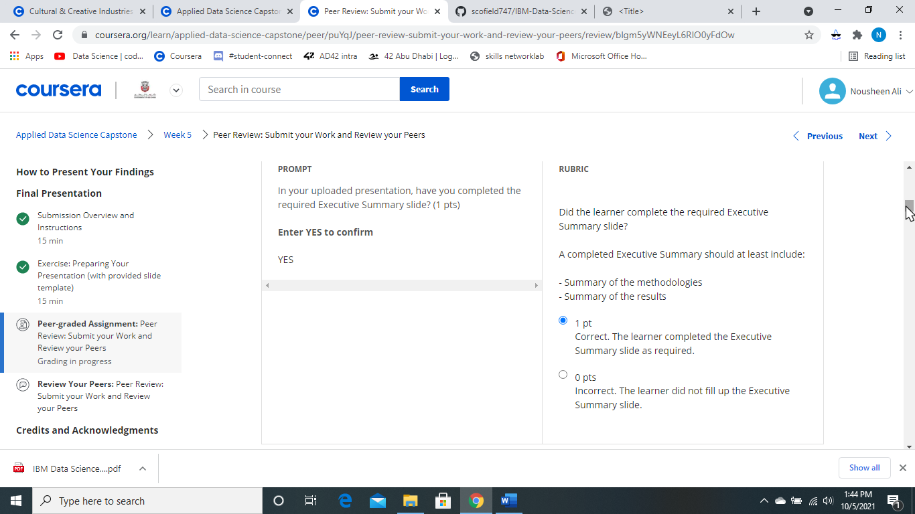

* Completed the required Introduction slide (1 pt)

- Project background and context - Problems you want to find answers

* Completed the required data collection and data wrangling methodology related slides (1 pt)
* 1. Data collection-SpaceX API: Presented the SpaceX API calls using flowcharts and key phrases and provided the GitHub URL of the completed REST API lab 2. Data collection-Web scraping: Presented the Web scraping workflow using flowcharts and key phrases and provided the GitHub URL of the completed REST API lab 3. Data wrangling methodology: Described how the collected data were processed using flowcharts and key phrases and provided GitHub URLs to the completed data-wrangling lab
* 
* 1 pt
* Correct. The learner completed all data collection and wrangling methodology slides requirements.
* 
* 0 pts
* Incorrect. The learner did not fill up any methodology slides.
* Completed the required EDA and interactive visual analytics methodology related slides (3 pts)

1. EDA with data visualization: Summarized what charts were plotted and why used those charts. Also added the GitHub URL of the completed EDA with data visualization lab 2. EDA with SQL: Summarized performed SQL queries and added the GitHub URL of the completed EDA with SQL lab 3. Interactive visual analytics: Summarized the completed Folium map and Ploty Dash application. Also added the GitHub URLs of the completed Folium and Plotly Dash applications

* Completed the required predictive analysis methodology related slides (1 pt)

- Presented how they built, evaluated, improved, and found the best classification model using key phrases and flow charts - Added the GitHub URL of the completed predictive analysis lab

* Completed the required EDA with visualization results slides (6 pts)

Did the learner complete the following 6 EDA with visualization-related slides? 1. Flight Number vs. Launch site scatter chart 2. Payload vs. Launch site scatter chart 3. Success rate vs. Orbit type bar chart 4. Flight Number vs. Orbit type scatter chart 5. Payload vs. Orbit type scatter chart 6. Launch success yearly trend line

* Completed the required EDA with SQL results slides (10 pts)

1. All launch site names: Find the names of the unique sites 2. Launch site names begin with `CCA`: Find all launch site names begin with `CCA` 3. Total payload mass: Calculate the total payload carried by booster from NASA 4. Average payload mass by F9 v1.1: Calculate the average payload mass carried by booster F9 v1.1 5. First successful ground landing date: find the date when the first successful landing outcome in ground pad 6. Successful drone ship landing with payload between 4000 and 6000: List the names of boosters which have success in drone ship and have payload greater than 4000 but less than 6000 7. Total number of successful and failure mission outcomes: Calculate the total number of successful and failure mission outcomes 8. Boosters carried maximum payload: List the names of the booster which have carried the maximum payload mass 9. 2015 launch records: List the launch records for months in 2015 10. Rank success count between 2010-06-04 and 2017-03-20: Rank the count of successful landings between 2010-06-04 and 2017-03-20

* Completed the required interactive map with Folium results slides (3 pts)

1. Screenshot and explanations of all launch sites’ markers on a global map 2. Screenshot and explanations of all launch records per site on the map 3. Screenshot and explanations of launch sites’ proximities such as railway, highway, coastline, with distance calculated and displayed

* Completed the required Plotly Dash dashboard results slides (3 pts)

1. Screenshot and explanations of launch success count for all sites, in a piechart 2. Screenshot and explanations of the piechart for the launch site with the highest launch success ratio 3. Screenshot and explanations of Payload vs. Launch outcome scatter plot for all sites

* Completed the required predictive analysis (classification) results slides (6 pts)

1. KNN 2. Logistic regression 3. Decision tree 4. SVM 5. Explain which model has the best accuracy 6. Display and explain the confusion matrix of the best model

* Completed the required Conclusion slide (1 pts)

1. Summary of your findings from EDA with data visualization 2. Summary of your findings from EDA with SQL 3. Summary of your findings from interactive visual analytics 4. Summary of your classification model results

* Applied your creativity to improve the presentation beyond the template (1 pts)

1. Summary of your findings from EDA with data visualization 2. Summary of your findings from EDA with SQL 3. Summary of your findings from interactive visual analytics 4. Summary of your classification model results

* Displayed any innovative insights (1 pts)
* - Extra EDA tasks - Extra classification improvement and evaluation methods - Extra dashboard components - Any other insights that impressed you